Weekly Construction Progress Report – Week 28
Harrow Bay Offshore Wind · 06 Jul – 12 Jul 2026
Elena Márquez · 13 July 2026 · HB-PM-RPT-2026-W28

1. Summary
No piling this week (seasonal piling restriction). The total remains 10 of 40 monopiles. The foundation campaign is 2 piles behind the Rev 2 baseline (12 planned). No weather downtime – MV Sea Atlas in port.
Area | Status | Comment
Overall schedule | Amber | 10/40 monopiles vs. 12 planned
Foundations | Amber | TPs installed: 10
Offshore substation | Green | Jacket installed 27 Jun
Cables | Green | Manufacturing on schedule
HSE | Amber | Recordable case

2. Progress
Metric | This week | Cumulative | Plan (cum.) | Variance
Monopiles installed | 0 | 10 | 12 | -2
Transition pieces installed | 0 | 10 | – | –
Waiting on weather (h) | 0 | 213 | – | –
Persons on board (avg.) | 39 | – | – | –
Man-hours MV Sea Atlas | 3,444 | 110,396 | – | –
Lost time injuries | 0 | 0 | 0 | 0
Recordable injuries | 1 | 1 | – | –
Near misses reported | 0 | 3 | – | –
HSE observation cards | 17 | – | – | –

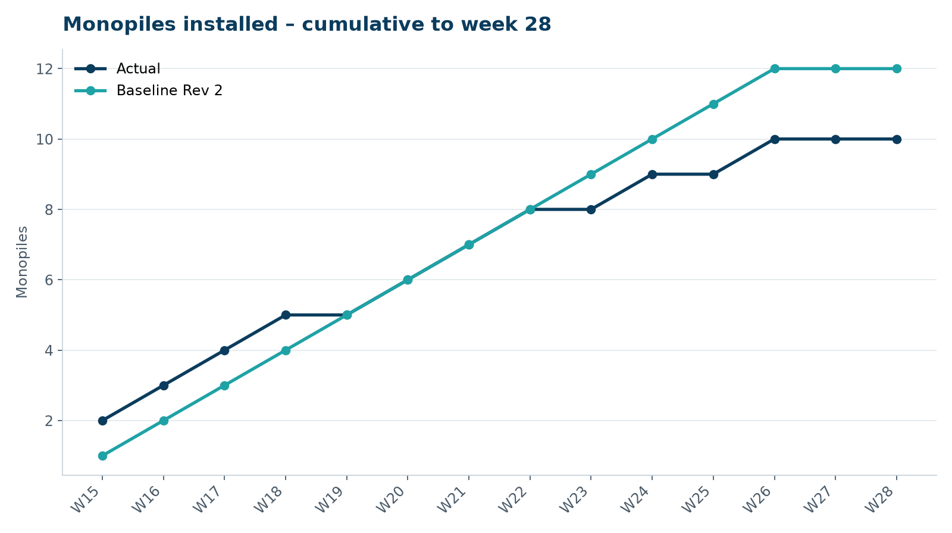
Figure 1 – Monopile installation progress, W15 to W28

3. Key activities this week
- MV Sea Atlas in port for planned maintenance: crane slew bearing inspection, leg and spudcan inspection, hammer overhaul.
- Pre-lay survey of the export cable corridor (KP 0 to KP 31) started with a survey vessel.
- No piling – seasonal restriction.

4. Health and safety
No lost time injuries. Medical treatment case on 8 July: finger laceration during hammer overhaul in port (Atlas Marine technician), three stitches, returned to work next day. 17 observation cards submitted; top theme: access to the TP platform.

5. Environment
- No piling this week; passive acoustic monitoring stations HB-PAM-01 to -04 operational.

6. Issues and risks
- HB-RISK-001 weather: 0 h downtime this week.

7. Look-ahead next week
Complete maintenance; boulder clearance planning.
Prepared by Project Controls (Gareth Lewis); approved by Elena Márquez. Distribution: project team, Steering Committee, Halden Turbine Systems, Lenders' Technical Adviser.

